No More Plastic
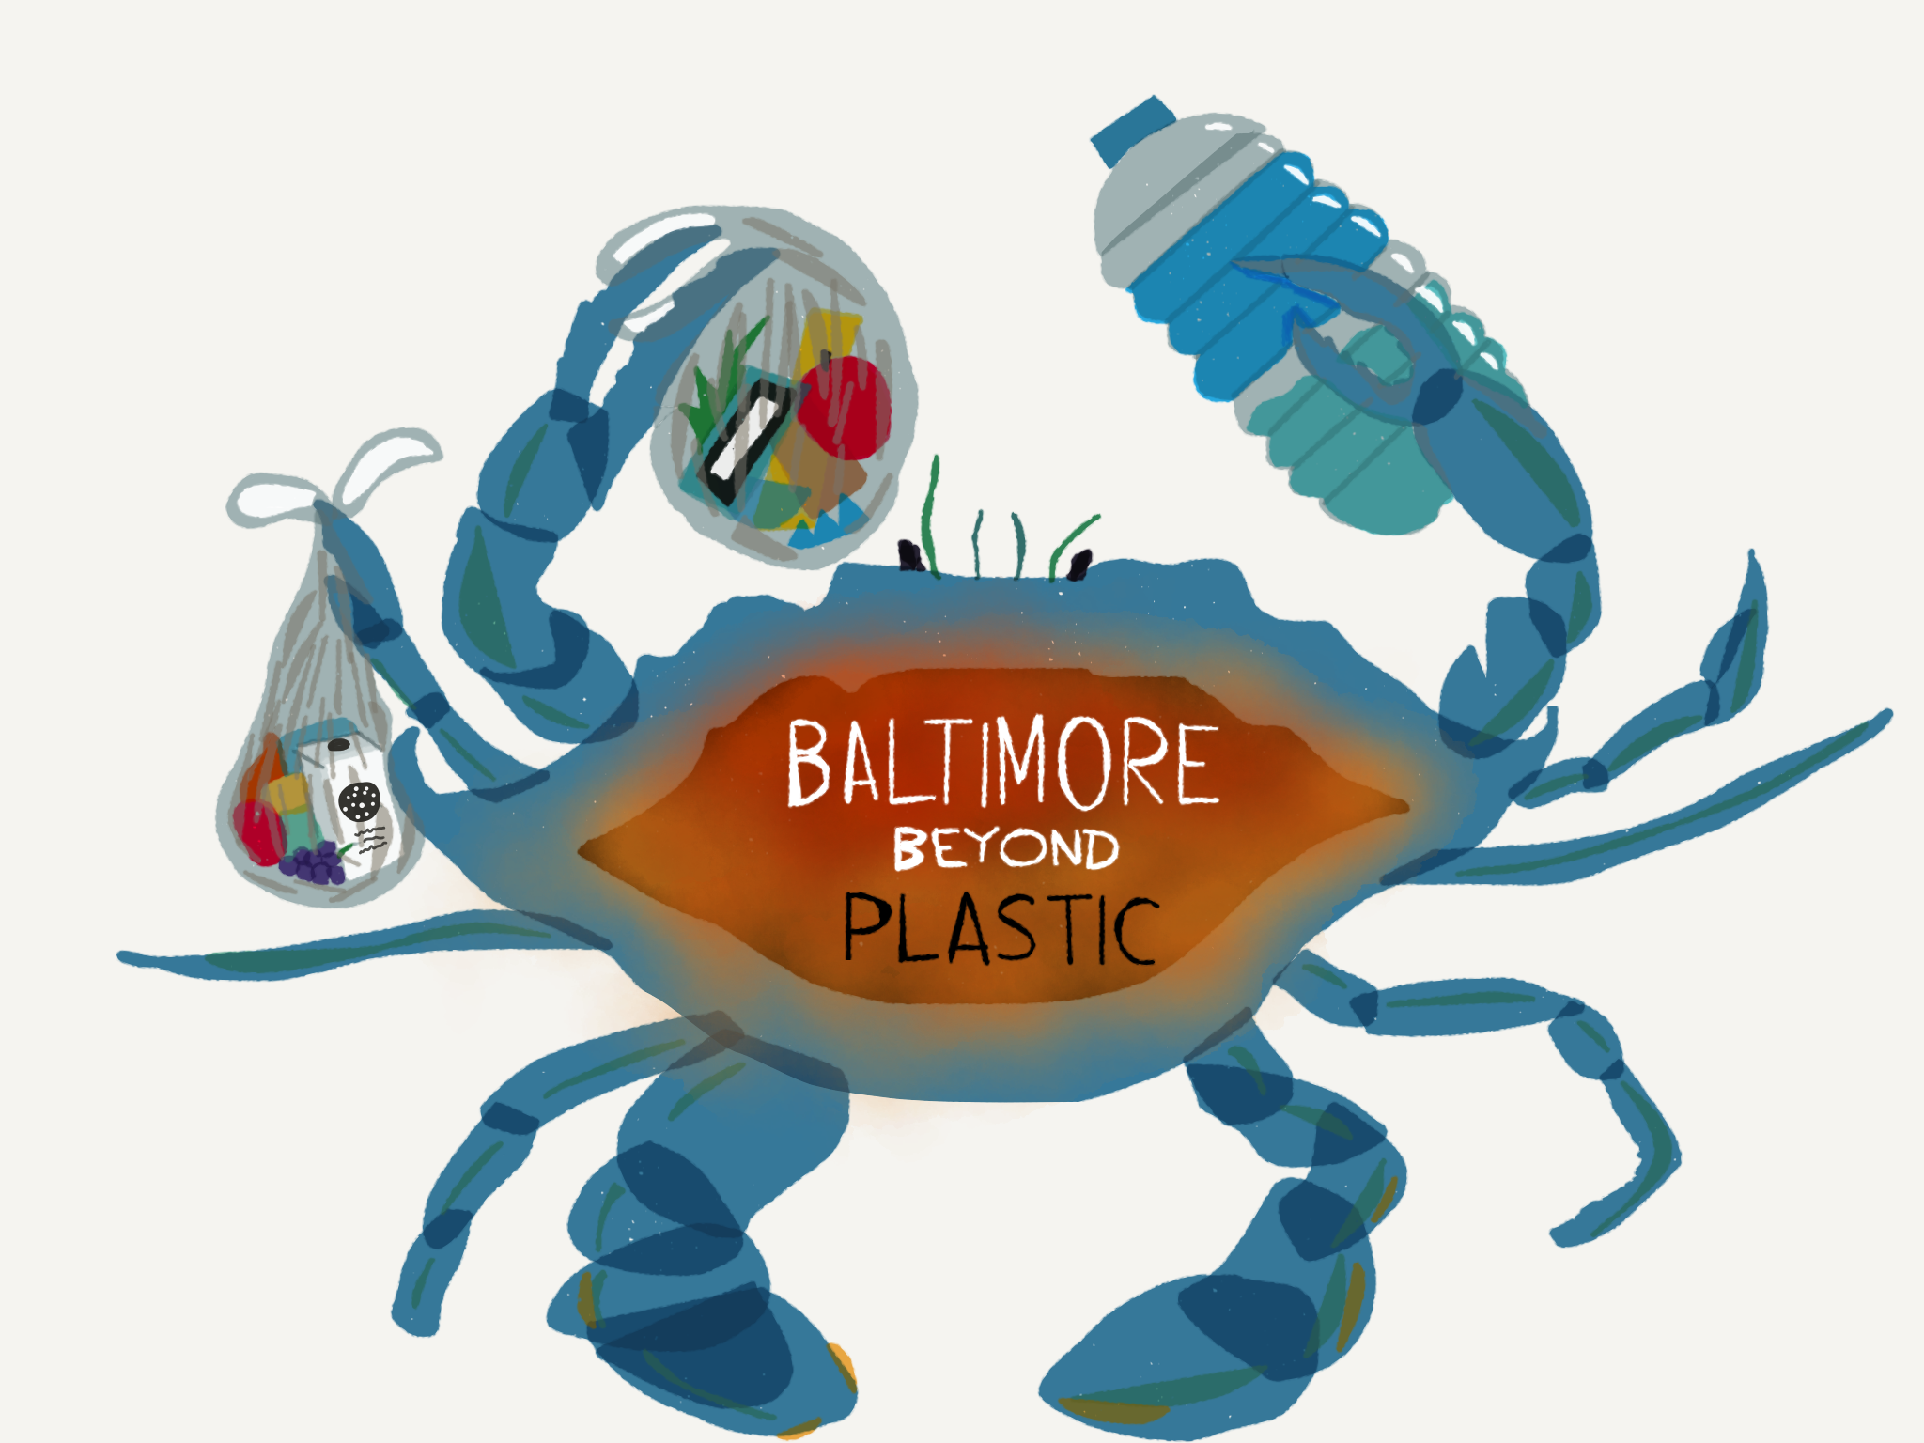
Tired of seeing trash in Baltimore?
Join Baltimore Beyond Plastic,
the new youth-led initiative
to stop pollution in our city.
Visit www.bmorebeyondplastic.org,
or text @bmorebeyond to 81010.

